**Process Report**

“MediaBazaar”

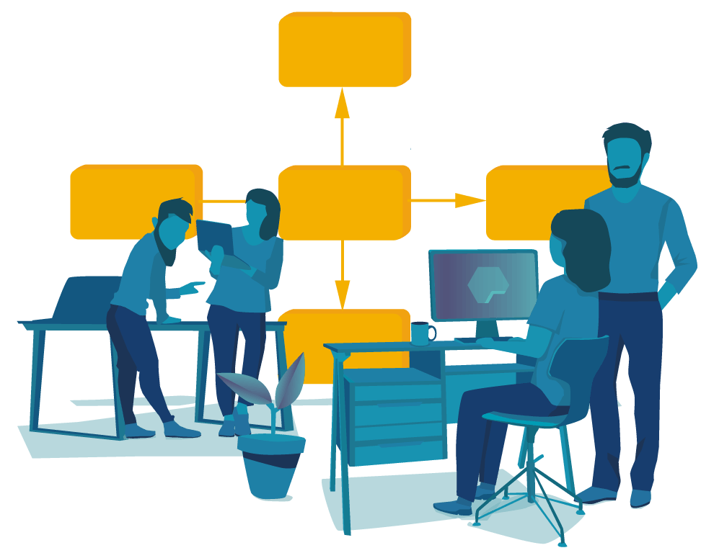

Student| Student number:

I B | x

Tudor Rusu | x

E P| x

V K| x

Tutor: Chung Kuah

FONTYS UNIVERSITY OF APPLIED SCIENCES

**HBO-ICT: English Stream**

May 2024

Table of Contents

Work division 2

Personal reflection 3

Ivona Bogovic 3

Tudor Rusu 4

Edita Pronckute 5

Viktor Kalinkov 6

Reflection about Iterations 7

# Work division

In the beginning we tried splitting our work into groups of two, to help facilitate communication and fasten our progress. Thus, I and V were responsible for the website part, Tudor and E for the remaining improvements to the application.

When the first group ran into problems they join in the second to finish the application faster and then fix the calendar issues, however we did not manage to do it faster, leaving the calendar to be neglected till the very end.

Just as before I. was still responsible for preparing Minutes of each Meeting (MOM) as no one else wanted to step up for this activity. Though, most of us were still making notes that we would later share and discuss before sending out MOM.

# Personal reflection

## I B

During these iterations we noticed a positive difference between waterfall and iteration methodology. Unfortunately, we started to have troubles with keeping up with the general workload and started to fall behind with deliverables.

Personally, I like how iterations work. One of our issues before was seeing a whole picture at the beginning of the project, but this was made easier this time since each iteration would have a few tasks and we would focus only on them. However, due to assignments from other subject we started to have problems splitting up tasks, hence having some tasks stretched through more iterations. Our tutor introduced us to GitLab Boards with issues representing different tasks we had to implement. This made organizing much easier.

To summarize everything, at the end the group managed to deliver everything on time, but we still need to overcome the obstacles mentioned above.

## Tudor Rusu

Pros:

During this iteration, the thing I liked is most that we divided the work evenly. Another positive thing to mention will be that whenever we encountered problems that stopped us progressing we helped each other and because of this we were able to learn extra things. In my opinion iterative methodology suits us better giving the fact that we are beginners but on the other hand it made me appreciate more the Waterfall one and the documentation we did because it sets long term goals and it’s gives you a better view on how the final product should look like.

Cons:

Although it should have been the opposite I feel like during this period we have prioritize our work as we were supposed to, but we also learned a lot from this. During this iteration I feel like we neglected the project just to catch up with the other courses.

## E P

During this part of the project we were struggling to keep up with the general workload and therefore got behind with certain functions. It is clearly becoming more challenging for us to work remotely, communicate and organize our work.

The idea of iterations I personally liked a lot. The way it was organized was almost reflecting the Agile principles and looked a bit like scrum framework. I like the shared discussion on what our focus for each iteration will be. When the goals are set more short-term it feels more relevant, making us more flexible with our ideas. It was also beneficial that we were able to ask Client related questions to the tutor. We started using GITLab boards by writing down short user interaction stories. This helped us better visualize the functions we need to implement, however, not all members were following them.

Overall, even though, due to internal (personal) struggles we could not keep up our usual pace. I still believe in my team and our potential, yet not being able to see each other in the long run is really starting to take its toll.

## V K

After the week 6 when we changed our method of work, in my opinion we did very well. Sometimes the tow of the corona virus played a big part because we must do it separated on our own sides, but we still managed. The workflow is going well, and we are proud of what we made. Sometimes we miscommunicate but quickly get on our feet and work on it. We correct every error we find and make meeting with each other to see the work and its progress. It is almost like the first 6 weeks but this time we had more freedom for our choices. This helped us by expressing our opinions better and making the application work. The fact that sometimes we are not free because of personal problem did not affect our teamwork at all. Personally, I trust my team and I hope they trust me. The teamwork has been better than the ones I had in the past projects. Communication is always possible as they are always online and always ready to work if needed. Having trouble with something is not a problem because we sit together and give our ideas until we manage to solve it.

In conclusion, the work was freer in a programing sense. The working prosses did not change a lot, by that I mean we still work as a team. The work ethic did not change only the scheduling of our work because not everyone can manage to be online every day. We try to the work on time even if some hiccups appear. If an obstacle appears, we try to resolve it as quick as possible.

# Reflection about Iterations

The part II of the project has been organized into iterations. Each iteration lasts 3 weeks making in total 6 iterations. After first two weeks we are reflecting on how it went.

With this approach we have been given the freedom to set up our own goals under the careful supervision and guidance from the tutor. Each iteration starts with deciding what functions to implement and deciding how to do it. Then, we solely focus on implementation of all agreed functions. Last week of iteration is about testing the implemented function and fixing any issues. This was a nice approach that made us more aware of what needs to be done each time.

On the other hand, the solutions became more complex and having more time to tackle them made us somewhat sloppy. We were not slacking completely but rather focusing more on the other subject and assignments. Which made our project progress suffer.

Overall, we found this approach more favorable, even if we struggled a bit to keep up.